Portable Onsite Customer Feedback
As an executive of a chain operation, you have realized the critical need for an instantaneous high quality high volume customer feedback system. Such a system is required for you to be on top of the customer experience management based on the live quality metrics. Forrester research study reports that a well designed (customer friendly) system can bring millions in additional revenue. Quickly identifying any chronic customer issues and then helping to resolve them in a timely manner, our system will help you to retain and grow your loyal customer base.

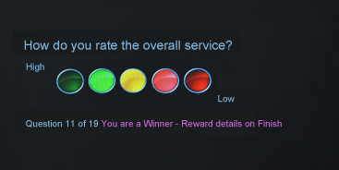

Differentiation:
The current feedback collection approach (email, phone, website or comment card) is tedious at best. That is why we designed a revolutionary 7 inch tablet based solution - that is absolutely simple to use and to manage. Our random reward option helps to a create scratch ticket excitement and marketing buzz every day, much better than other the email promotions. Our IntelliProbe feature allows a customer to complete a survey with as few as one question – in seconds. The customer just makes selections - no data entry about your visit or computer navigation is required.

Management Portal:
Our highly secure management portal is designed with functional tabs for easy analysis and visualization (graphs, pie charts). Custom feed is available for your backend processing. You can create, edit and deploy surveys quickly without any IT help. Edit your questions and then launch selected surveys across all your locations with the click of a button. Review your customer comments for quick corrective action instantly from anywhere. Configure for live alerts based on trends or low ratings.

Benefits:
We have developed a premium purpose-built system for multi-location experience management - it scales from one to hundreds and thousands of locations with the same ease. Our pre-configured tablet does not need any downloads or any operational instructions or staff training. On power up of the tablet, it lands on the START button page of the survey automatically. With our system you can expect high quality high volume feedback instantly - because you have made it easy, fun and exciting for your customers.

